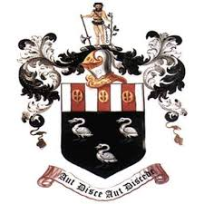
Hutton Grammar Sixth Form Prospectus information

Department: ENGLISH

Subject: ENGLISH LANGUAGE AND LITERATURE COMBINED

What topics are covered in this subject?

On this course you will undertake the close study of literary and linguistic issues covering all three genres of prose, poetry and drama, whilst also encountering a wide range of nonfiction. Modern and pre-twentieth century texts are studied, all of which are selected for their challenging natures both in terms of their style and subject matter. You will also further your linguistic studies in the analysis of speech and its representation.

How is this subject taught?

Lessons are often lively and discussion-led and we welcome students who are keen to think independently and share those ideas within lessons. As part of the A Level course, students undertake their own independent study, with the opportunity to select and analyse texts that inspire and motivate on a personal level. Students are formally assessed in two external examinations at the end of the course.

What are the enrichment opportunities in this subject?

English Language and Literature students are offered an array of opportunities to suit their personal interests and prepare them for the future. Theatre visits, guest literary lecturers and writing competitions are offered throughout your time in Sixth Form. Opportunities to work with younger students are provided and students relish the chance to share their love of literature with others, through shared reading and by coordinating activities beyond their own study. Students may also wish to partake in the Sixth Form’s Debating Society which enables students to think critically and to shape their arguments in a convincing, stylish manner
Where does this subject lead at 18+?

A Level English is accepted as an entry qualification for all but the most specialised university degree courses and is a sensible subject to accompany most other A Level choices. Studying English teaches you to think analytically, read complex texts with understanding and express your ideas clearly and accurately. These are skills which are highly valued in all walks of life. Career options are varied including jobs in drama and theatre, writing, publishing, journalism, marketing, PR, advertising and teaching. The qualification can also be useful in business and the legal profession.

