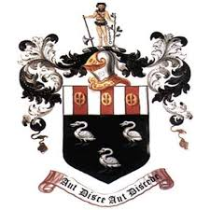
Hutton Grammar Sixth Form Prospectus information

Department: Geography

Subject: Geography

What topics are covered in this subject?
We study the following topics in A level Geography at Hutton:
Regenerating Places
Globalisation
Glaciation
Tectonics
Water Cycle
Carbon Cycle
Superpowers
Migration, National Identity & Sovereignty

How is this subject taught?
Content is delivered through lessons with two experienced teachers. Each unit is tested at the end in a short exam. Ongoing assessments include presentations, videos, short exam questions, essays and projects.
Wider reading is essential in order to broaden your understanding of the complexities involved in both disciplines of Geography.
There is an independent NEA (coursework) element in Year 13 which enables students to pursue an area of geography that they enjoy and have a passion for.

What are the enrichment opportunities in this subject?
There is a two day trip to London in which physical and human geography is looked into.
There is a national Young Geographer competition which is open to Years 12 & 13.
We have guest speakers from Edge Hill University and the opportunity to visit Liverpool Hope University’s Geography Department.
There are trips to Formby, Preston, Morecambe, Liverpool and The Lake District.

Where does this subject lead at 18+?

A geography degree enables you to embark on a career in a range of fields, including those in the education, commerce, industry, transport, tourism and public sectors. You'll also have many transferable skills, attracting employers from the business, law and finance sectors.

