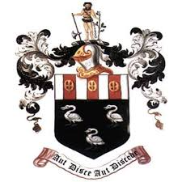
Hutton Grammar Sixth Form Prospectus information

Department: Performing Arts

Subject: Music

What topics are covered in this subject?
The Music A Level is split into three areas:
- Appraising Music - Through this we look at everything from Beethoven to Muse, from the Classical era to Broadway Musicals and everything in between.
- Performance - Through this you will learn to shape your own personal performance.
- Composition - In this topic we will look at how compositions are put together. Looking at techniques and putting them into practice.
How is this subject taught?
Lessons will be taught with a mixture of theory and practical application. You will have time in class to work on your portfolio and will be expected to practice your instrument for the performance aspects of the course.
You are assessed over the three topic areas, Appraising Music is assessed through a listening exam. For Composition you will be required to complete two pieces, one a free composition and the other to a brief. Your Performance is assessed by a 10 minute recital at the end of your second year.
What are the enrichment opportunities in this subject?
Music offers a rich array of extracurricular opportunities. There are many music clubs, from bands to vocal groups that you will be able to take advantage of. We run a large scale, full musical, every two years and look to the sixth form to carry much of the weight of that, with music students often taking lead roles or playing a part in the orchestra.
We also run a yearly residential; in this we take all musicians away for a weekend of rehearsals, where hopefully you will have some fun and try new things in a safe and creative environment.
Where does this subject lead at 18+?
Music is a very desirable subject for all further studies. It gives you many transferable skills that you could use to study music further or take with you into whatever further studies or employment you like.

