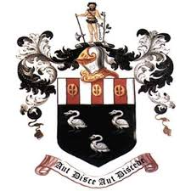
Hutton Grammar Sixth Form Prospectus information

Department: Religious Studies

Subject: Religious Studies

What topics are covered in this subject?
Religious Studies is an interesting and intellectually challenging A level because its study raises many questions about God, the world around us and the historical and spiritual significance of the New Testament. Religious Studies also develops a variety of skills, including those of analysis, discussion and debate. The valuable skills of logical argument and critical evaluation are also developed and can be transferred to other areas of study. Religious Studies is a useful stepping stone to many careers because it encourages an understanding of what people believe and how it affects their lives. Units of study include: Philosophy of Religion, Ethics and New Testament Studies.
How is this subject taught?
Religious Studies is taught in a classroom setting through a variety of methods including debate and discussions, lectures and media clips, independent research and activities, partner and group tasks.

What are the enrichment opportunities in this subject?
The Religious Studies Department is always looking to enrich the experiences and learning of students who take our course and so this varies from year to year. Currently Religious Studies offers opportunities to link with universities, such as the University of Chester and students are invited to attend university sessions and conferences. We invite speakers, such as members of the clergy, into 6th form to explain and expand on deep theological concepts.
Where does this subject lead at 18+?
A Level Religious Studies is a well-recognised and respected qualification. Students aspiring to careers in politics or law will benefit from learning how to present arguments clearly and logically. Religious Studies also gives students an appreciation and understanding of alternative points of view and is therefore very useful for careers in medicine, public services, social work or education. Journalism and publishing are also possible career routes for those who have studied Religious Studies at A Level.

