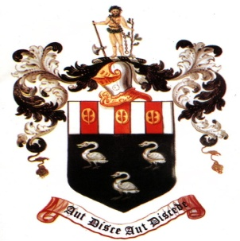

**Hutton C of E Grammar School**

**Emergency Evacuation Procedure during Exams**

If the Fire Alarm sounds whilst you are sitting an exam it is important that you follow the Invigilator’s instructions to ensure that

a) no malpractice takes place

b) you will be able to continue with the exam when the ‘all clear’ is given

The following procedure will apply if you are in an exam:

* You will be told to put your pens down & close all booklets.
* The Invigilator will note the time that the exam is interrupted.
* All exam question and answer papers and materials should be left on your exam desk and NOT taken with you.
* No bags or personal belongings should be taken with you.
* You will be asked to walk in single file to the MUGA.
* UNDER NO CIRCUMSTANCES should you talk to anyone. You could risk disqualification.
* DO NOT join your form. You will be asked to form a line next to the MUGA entrance and a register will be taken.
* Once the ‘All Clear’ is given you will be escorted, in silence, back to the exam room.
* Back in Exam Room – You will be asked to return to your seat to re-start the exam. The finish time will be changed to take account of the interruption.

Liverpool Road

Visitor

Car

Park

M Greenall

Exams Officer

MUGA Entrance

Gate

E

X

A

M

S